LAMPIRAN

Lampiran 1. Script program data Visual Studio

Berikut adalah Script program data Visual Studio :
Form Perhitungan Intensitas Konsumsi Energi (IKE)

Form ike
Imports System.Data.OleDb
Public Class Form1
Dim objike As New ClsIKE
Private Sub Form1_Load(ByVal sender As System.Object, ByVal e As System.EventArgs) Handles MyBase.Load
txtekwhthn.Focus()
txtIKE.Text = Format(Val(txtIKE.Text))
txtid.Text = objike.AutoNumber()
End Sub
Private Sub txtIKE_TextChanged(ByVal sender As System.Object, ByVal e As System.EventArgs) Handles txtIKE.TextChanged

End Sub

Private Sub btnhitung_Click(ByVal sender As System.Object, ByVal e As System.EventArgs) Handles btnhitung.Click
txtIKE.Text = txtekwhthn.Text / txtluasbangunan.Text
End Sub

Private Sub cbjenis_SelectedIndexChanged(ByVal sender As System.Object, ByVal e As System.EventArgs)
'If cbjenis.Text = "Perkantoran" Then
' If txtIKE.Text < 240 Then
' txtket.Text = "EFISIEN"
' ElseIf txtIKE.Text > 240 Then
' txtket.Text = "BOROS"
' End If

'ElseIf cbjenis.Text = "Pusat Belanja" Then
' If txtIKE.Text < 330 Then
' txtket.Text = "EFISIEN"
' ElseIf txtIKE.Text > 330 Then
' txtket.Text = "BOROS"
' End If

'ElseIf cbjenis.Text = "Hotel / Apartemen" Then
' If txtIKE.Text < 300 Then
' txtket.Text = "EFISIEN"
' ElseIf txtIKE.Text > 300 Then
' txtket.Text = "BOROS"
' End If

'ElseIf cbjenis.Text = "Rumah Sakit" Then
' If txtIKE.Text < 380 Then
' txtket.Text = "EFISIEN"
' ElseIf txtIKE.Text > 380 Then
' txtket.Text = "BOROS"
' End If
'End If

'ElseIf cbjenis.Text = "perkantoran"(txtIKE.Text > 240) Then
' txtket.Text = "EFISIEN"
'End If

'If cbjenis.Text = "Pusat Belanja" > 330 Then
' txtket.Text = "BOROS"
'ElseIf cbjenis.Text = "Pusat Belanja" < 330 Then
' txtket.Text = "EFISIEN"
'End If

'If cbjenis.Text = "Hotel / Apartemen" > 300 Then
' txtket.Text = "BOROS"
'ElseIf cbjenis.Text = "Hotel / Apartemen" < 300 Then
' txtket.Text = "EFISIEN"
'End If

'If cbjenis.Text = "Rumah Sakit" > 380 Then
' txtket.Text = "BOROS"
'ElseIf cbjenis.Text = "Rumah Sakit" < 380 Then
' txtket.Text = "EFISIEN"
'End If
End Sub

Private Sub btnkantor_Click(ByVal sender As System.Object, ByVal e As System.EventArgs)
If txtIKE.Text < 240 Then
txtket.Text = "EFISIEN"
txtket.BackColor = Color.PaleGreen
ElseIf txtIKE.Text > 240 Then
txtket.Text = "BOROS"
txtket.BackColor = Color.Tomato
End If
End Sub

Private Sub Btnmall_Click(ByVal sender As System.Object, ByVal e As System.EventArgs)
If txtIKE.Text < 330 Then
txtket.Text = "EFISIEN"
txtket.BackColor = Color.PaleGreen
ElseIf txtIKE.Text > 330 Then
txtket.Text = "BOROS"
txtket.BackColor = Color.Tomato
End If

End Sub

Private Sub btnrs_Click(ByVal sender As System.Object, ByVal e As System.EventArgs)
If txtIKE.Text < 380 Then
txtket.Text = "EFISIEN"
txtket.BackColor = Color.PaleGreen
ElseIf txtIKE.Text > 380 Then
txtket.Text = "BOROS"
txtket.BackColor = Color.Tomato
End If

End Sub

Private Sub btnhapus_Click(ByVal sender As System.Object, ByVal e As System.EventArgs) Handles btnhapus.Click
txtekwhthn.Clear()
txtIKE.Clear()
txtket.Clear()
txtluasbangunan.Clear()
txtekwhthn.Focus()
txtket.BackColor = Color.White
txtstnd.Clear()
CBJenistempat.Text = ""

txtid.Text = objike.AutoNumber()
End Sub

Private Sub bersih()
txtekwhthn.Clear()
txtIKE.Clear()
txtket.Clear()
txtluasbangunan.Clear()
txtekwhthn.Focus()
txtket.BackColor = Color.White
txtstnd.Clear()
CBJenistempat.Text = ""

txtid.Text = objike.AutoNumber()
End Sub
Private Sub CBJenistempat_SelectedIndexChanged(ByVal sender As System.Object, ByVal e As System.EventArgs) Handles CBJenistempat.SelectedIndexChanged

If CBJenistempat.Text = "Perkantoran" Then
txtstnd.Text = 240
If txtIKE.Text > 240 Then
txtket.Text = "BOROS"
txtket.BackColor = Color.Tomato
ElseIf txtIKE.Text < 240 Then
txtket.Text = "EFISIEN"
txtket.BackColor = Color.PaleGreen
End If

ElseIf CBJenistempat.Text = "Pusat Belanja" Then
txtstnd.Text = 330
If txtIKE.Text > 330 Then
txtket.Text = "BOROS"
txtket.BackColor = Color.Tomato
ElseIf txtIKE.Text < 330 Then
txtket.Text = "EFISIEN"
txtket.BackColor = Color.PaleGreen
End If

ElseIf CBJenistempat.Text = "Hotel / Apartemen" Then
txtstnd.Text = 300
If txtIKE.Text > 300 Then
txtket.Text = "BOROS"
txtket.BackColor = Color.Tomato
ElseIf txtIKE.Text < 300 Then
txtket.Text = "EFISIEN"
txtket.BackColor = Color.PaleGreen
End If

ElseIf CBJenistempat.Text = "Rumah Sakit" Then
txtstnd.Text = 380
If txtIKE.Text > 380 Then
txtket.Text = "BOROS"
txtket.BackColor = Color.Tomato
ElseIf txtIKE.Text < 380 Then
txtket.Text = "EFISIEN"
txtket.BackColor = Color.PaleGreen
End If

End If
End Sub

Private Sub Button2_Click(ByVal sender As System.Object, ByVal e As System.EventArgs) Handles Button2.Click
objike.pid = txtid.Text
objike.pkwhthn = txtekwhthn.Text
objike.plbangunan = txtluasbangunan.Text
objike.pike = txtIKE.Text
objike.pjtempat = CBJenistempat.Text
objike.pstandarisasi = txtstnd.Text
objike.pket = txtket.Text

If objike.simpan = 1 Then
MessageBox.Show("Data Berhasil Disimpan", "Berhasil")
bersih()
txtid.Text = objike.AutoNumber()
Else
MessageBox.Show("Data Gagal Disimpan", "Gagal")
End If

bersih()
txtid.Text = objike.AutoNumber()
txtid.Enabled = True
BCari.Enabled = True
txtekwhthn.Focus()
End Sub

Private Sub Bcari_Click(ByVal sender As System.Object, ByVal e As System.EventArgs) Handles Bcari.Click
Dim oPop As New frmpopupike
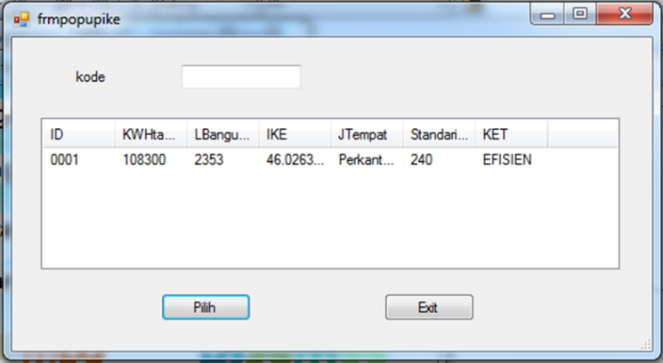
oPop.ShowDialog()
If oPop.Rid <> "" Then
txtid.Text = oPop.Rid
txtekwhthn.Text = oPop.Rkwhtahun
txtluasbangunan.Text = oPop.RLbangunan
txtIKE.Text = oPop.RIKE
CBJenistempat.Text = oPop.RJTempat
txtstnd.Text = oPop.RStandarisasi
txtket.Text = oPop.RKET

txtid.Enabled = False
Button2.Enabled = False
txtekwhthn.Focus()
End If
End Sub
Private Sub Label1_Click(ByVal sender As System.Object, ByVal e As System.EventArgs) Handles Label1.Click

End Sub
End Class
Pada gambar 4.24 terdapat fitur “simpan perhitungan” yaitu berfungsi untuk menyimpan data yang telah kita gunakan pada program, dan diatas juga terdapat “Id hitung” yaitu untuk kode dimana kita menyimpan database dan bisa kita cari dengan mudah seperti pada gambar 4.24 dibawah ini:

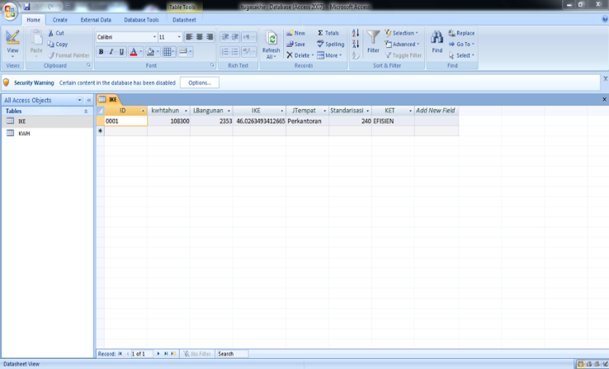

Gambar 1.8 Tampilan hasil perhitungan yang telah disimpan

Dan database yang telah terisimpan bisa diakses di Microsoft Access seperti gambar 1.9 dibawah ini:

Gambar 1.9 Tampilan database pada Microsoft Access

Gambar 1.10 adalah tampilan program simulasi perhitungan untuk mengetahui penggunaan biaya energi dan kWh.

Berikut cara Perhitungan kWh dan Biaya Energi. Data-data yang diketahui adalah sebagai berikut.
Dimana:$E(kWh/hari)=\frac{Pw . t(h/hari)}{1000(W/kW)}$
E= Energi dalam kilowatt-hours (kWh).
P= Konsumsi daya dalam Watts.
T= Waktu penggunaan per hari.
W= Watts.
kW= Kilowatt.
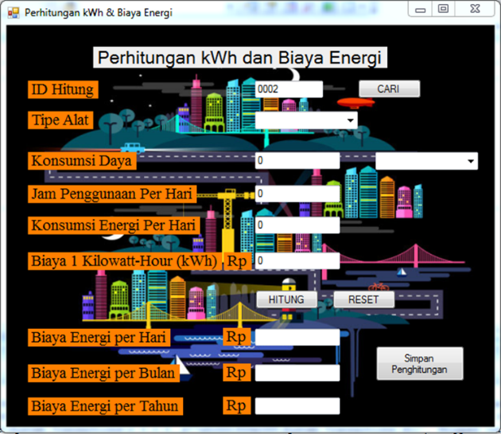

Gambar 1.10 Tampilan Perhitungan kWh dan Biaya Energi

Adapun perintah-perintah yang digunakan dalam menyusun program untuk Perhitungan kWh dan Biaya Energi dapat dilihat dibawah ini.
Form Perhitungan kWh dan Biaya Energi
Public Class Form2

Imports System.Data.OleDb
Public Class Form2
Dim objkwh As New ClskWh
Private Sub Form2_Load(ByVal sender As System.Object, ByVal e As System.EventArgs) Handles MyBase.Load
Koneksi()
txtid.Text = objkwh.Autonumber

cbbarang.Focus()
cbwatt.Enabled = False
txtcost.Text = Format(Val(txtcost.Text))

txtpower.Text = Format(Val(txtpower.Text))

txtpenggunaan.Text = Format(Val(txtpenggunaan.Text))

Txtkonsumsi.Text = Format(Val(Txtkonsumsi.Text))
End Sub
Private Sub cbbarang_SelectedIndexChanged(ByVal sender As System.Object, ByVal e As System.EventArgs) Handles cbbarang.SelectedIndexChanged
If cbbarang.Text = "KIPAS" Then
txtpower.Text = 70
End If

If cbbarang.Text = "STRIKA" Then
txtpower.Text = 2400
End If
If cbbarang.Text = "MICROWAVE" Then
txtpower.Text = 800
End If
If cbbarang.Text = "AC" Then
txtpower.Text = 2000
End If
If cbbarang.Text = "DEKSTOPCOMPUTER" Then
txtpower.Text = 500
End If
If cbbarang.Text = "LAPTOP" Then
txtpower.Text = 200
End If
If cbbarang.Text = "TELEVISI" Then
txtpower.Text = 70
End If
If cbbarang.Text = "KULKAS" Then
txtpower.Text = 200
End If
cbwatt.Enabled = True
End Sub

Private Sub Txtkonsumsi_TextChanged(ByVal sender As System.Object, ByVal e As System.EventArgs) Handles Txtkonsumsi.TextChanged

End Sub

Private Sub Button1_Click(ByVal sender As System.Object, ByVal e As System.EventArgs) Handles Button1.Click

txtcosthari.Text = Txtkonsumsi.Text * txtcost.Text
txtcostbulan.Text = txtcosthari.Text * 30
txtcosttahun.Text = txtcostbulan.Text * 12

txtcosthari.Text = Format(Val(txtcosthari.Text), "Rp, ###,###,###.00")
txtcostbulan.Text = Format(Val(txtcostbulan.Text), "Rp, ###,###,###.00")
txtcosttahun.Text = Format(Val(txtcosttahun.Text), "Rp, ###,###,###.00")

End Sub

Private Sub cbwatt_MouseClick(ByVal sender As Object, ByVal e As System.Windows.Forms.MouseEventArgs) Handles cbwatt.MouseClick
' pilih()
End Sub

Private Sub cbwatt_SelectedIndexChanged(ByVal sender As System.Object, ByVal e As System.EventArgs) Handles cbwatt.SelectedIndexChanged

pilih()
txtpenggunaan.Focus()
End Sub
Sub pilih()
If cbwatt.Text = "killowatts(kW)" Then
Txtkonsumsi.Text = txtpower.Text * txtpenggunaan.Text
End If
If cbwatt.Text = "watts(W)" Then
Txtkonsumsi.Text = (Txtkonsumsi.Text / 1000)
End If
End Sub

Private Sub txtpenggunaan_Enter(ByVal sender As Object, ByVal e As System.EventArgs) Handles txtpenggunaan.Enter
Txtkonsumsi.Text = ((txtpower.Text * txtpenggunaan.Text) / 1000)
pilih()
cbwatt.Enabled = True
End Sub

Private Sub txtpenggunaan_TextChanged(ByVal sender As System.Object, ByVal e As System.EventArgs) Handles txtpenggunaan.TextChanged
If txtpenggunaan.Text = "" Then
txtpenggunaan.Text = 0
End If
Txtkonsumsi.Text = ((txtpower.Text * txtpenggunaan.Text) / 1000)
pilih()
cbwatt.Enabled = True
txtcost.Focus()
End Sub

Private Sub Button2_Click(ByVal sender As System.Object, ByVal e As System.EventArgs) Handles Button2.Click

Txtkonsumsi.Text = "0"
cbbarang.Text = ""
txtpower.Text = "0"
cbwatt.Text = ""
txtcost.Text = "0"
txtcosthari.Text = ""
txtcostbulan.Text = ""
txtcosttahun.Text = ""
txtpenggunaan.Text = "0"

End Sub

Private Sub bersih()
Txtkonsumsi.Text = "0"
cbbarang.Text = ""
txtpower.Text = "0"
cbwatt.Text = ""
txtcost.Text = "0"
txtcosthari.Text = ""
txtcostbulan.Text = ""
txtcosttahun.Text = ""
txtpenggunaan.Text = "0"

End Sub

Private Sub Btnsimpan_Click(ByVal sender As System.Object, ByVal e As System.EventArgs) Handles Btnsimpan.Click
objkwh.pid = txtid.Text
objkwh.palattipikal = cbbarang.Text
objkwh.pkdaya = txtpower.Text
objkwh.ppengperhari = txtpenggunaan.Text
objkwh.pkonenergi = Txtkonsumsi.Text
objkwh.pbiayaperjam = txtcost.Text
objkwh.pbiayahari = txtcosthari.Text
objkwh.pbiayabulan = txtcostbulan.Text
objkwh.pbiayatahun = txtcosttahun.Text

If objkwh.simpan = 1 Then
MessageBox.Show("Data Berhasil Disimpan", "Berhasil")
bersih()
txtid.Text = objkwh.Autonumber()
Else
MessageBox.Show("Data Gagal Disimpan", "Gagal")
End If

bersih()

BtnCari.Enabled = True
cbbarang.Focus()

End Sub

Private Sub btncari_Click(ByVal sender As System.Object, ByVal e As System.EventArgs) Handles btncari.Click
Dim oPop As New FrmpopupKWH
oPop.ShowDialog()
If oPop.Rid <> "" Then
txtid.Text = oPop.Rid
cbbarang.Text = oPop.RAlattipikal
txtpower.Text = oPop.Rkdaya
txtpenggunaan.Text = oPop.Rpengperhari
Txtkonsumsi.Text = oPop.Rkonenergi
txtcost.Text = oPop.Rbiayaperjam
txtcosthari.Text = oPop.Rbiayahari
txtcostbulan.Text = oPop.Rbiayabulan
txtcosttahun.Text = oPop.Rbiayatahun

txtid.Enabled = False
Btnsimpan.Enabled = False
cbbarang.Focus()
End If
End Sub
End Class

